18/06/25

Python Coding Challenge

Topic: List, Tuple, Dictionary, Set | Total Questions: 10 | Time: 60 minutes

Section A: List (3 Questions)

Section B: Tuple (2 Questions)

Section C: Dictionary (3 Questions)

Section D: Set (2 Questions)

**Q1. Write a Python program to remove all duplicates from a list without using the set() function.**

**Input Example: [1, 2, 2, 3, 4, 4, 5]**

**Output: [1, 2, 3, 4, 5]**

CODE:

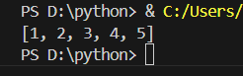mylist = [1, 2, 2, 3, 4, 4, 5]

new_list = list(dict.fromkeys(mylist))

print(new_list)

**Q2. Given a list of integers, write a program to find the second highest unique number.**

**Input Example: [12, 5, 9, 21, 21, 3]**

**Output: 12**

CODE:

a = [12, 5, 9, 21, 21, 3]

b=list(dict.fromkeys(a))

b.sort(reverse=True)

print(b[1])

**Q3. Rotate a list to the right by k positions.**

**Input: List = [1, 2, 3, 4, 5], k = 2**

**Output: [4, 5, 1, 2, 3]**

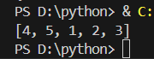CODE:

a = [1, 2, 3, 4, 5]

k = 2

print(a[-k:] + a[:-k])

**Q4. Write a Python program to multiply the elements of each tuple in a list of tuples and return a new list.**

**Input: [(2, 4), (3, 5), (4, 6)]**

**Output: [8, 15, 24]**

CODE:

a = [(2, 4), (3, 5), (4, 6)]

b = []

for x, y in a:

    b.append(x * y)

print(b)

**Q5. Given a tuple of integers, write a program to count how many times each element occurs.**

**Input: (1, 2, 2, 3, 1, 4, 2)**

**Output: {1: 2, 2: 3, 3: 1, 4: 1}**

CODE:

a = (1, 2, 2, 3, 1, 4, 2)

b = {}

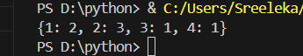for i in a:

    if i in b:

        b[i] += 1

    else:

        b[i] = 1

print(b)

**Q6. Write a Python program to count the frequency of each character in a string using a dictionary.**

**Input: 'banana'**

**Output: {'b': 1, 'a': 3, 'n': 2}**

CODE:

word = 'banana'

count = {}

for X in word:

    if X in count:

        count[X] += 1

    else:

        count[X] = 1

print(count)

**Q7. Merge two dictionaries such that common keys have their values summed.**

**Input: {'apple': 10, 'banana': 5}, {'banana': 3, 'orange': 7}**

**Output: {'apple': 10, 'banana': 8, 'orange': 7}**

CODE:

a = {'apple': 10, 'banana': 5}

b = {'banana': 3, 'orange': 7}

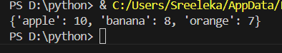for k in b:

    if k in a:

        a[k] += b[k]

    else:

        a[k] = b[k]

print(a)

**Q8. Given a dictionary of student names and their marks, print the name(s) of the student(s) with the highest marks.**

**Input: {'Alice': 85, 'Bob': 92, 'Carol': 92}**

**Output: ['Bob', 'Carol']**

CODE:

marks = {'Alice': 85, 'Bob': 92, 'Carol': 92}

high = max(marks.values())

t = []

for A in marks:

    if marks[A] == high:

        t.append(A)

print(t)

**Q9. Write a Python program to find all common elements among three lists using set operations.**

**Input: [1, 2, 3], [2, 3, 4], [3, 2, 5]**

**Output: {2, 3}**

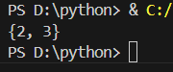CODE:

a = [1, 2, 3]

b = [2, 3, 4]

c = [3, 2, 5]

print(set(a) & set(b) & set(c))

**Q10. From a sentence entered by the user, extract and display all unique words using a set. Input: 'this is a test this is fun'**

**Output: {'this', 'is', 'a', 'test', 'fun'}**

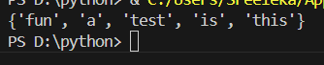CODE:

B = 'this is a test this is fun'

A = B.split()

print(set(A))